Directly Deploy EAR file to WebSphere Using Jenkins

This document shows how Jenkins plus a Websphere Plugin can deploy .EAR files to a local o remote WebSphere instance.
The WebSphere Deployer Plugin for Jenkins is needed to perform the deploys.
- Once Jenkins is setup with the plugin, we need to create a new project:

- Select Freestyle project

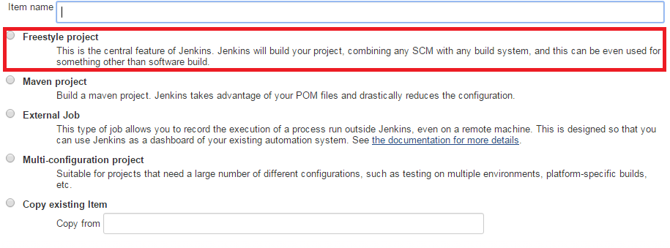
- Setup the Post-build Actions to Deploy to IBM WebSphere Application Server. You can specify the WebSphere IP, Connector Type and Port Number, target node, target cell, target server, target cluster.
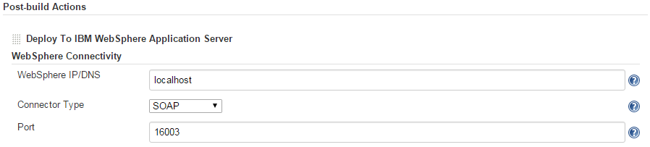

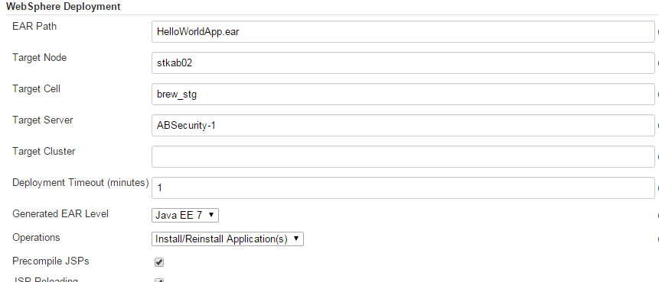

- Save the Project

- Once the Project is saved we need to copy the .EAR file specified in the EAR Path under WebSphere Deployment options (per this example is the HelloWorldApp.ear file. Go to /usr/apm/Jenkins/jobs/<job-name> (In this example is HelloWorld)

- Gp to the main Jenkins screen and press Build Now
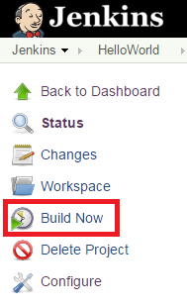

- Click on the Blue Ball next to the build job currently being run to see the Console Output

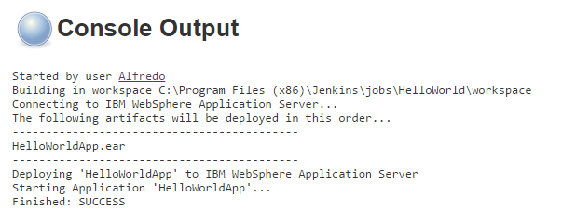
- Check on the WebSphere page for the installed application
